P 1 Single-Area OSPF Link Costs and Interface Priorities.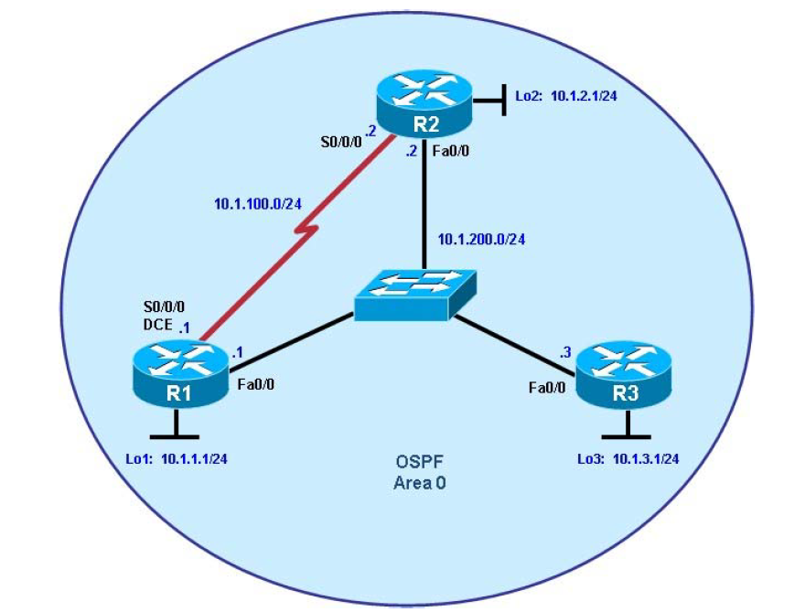
Background:
You are responsible for configuring the new network to connect your company’s engineering, marketing, and accounting departments, represented by the loopback interfaces on each of the three routers. The physical devices have just been installed and connected by Fast Ethernet and serial cables. Configure OSPF to allow full connectivity between all departments.

Objectives
• Configure single-area OSPF on a router.
• Advertise loopback interfaces into OSPF.
• Verify OSPF adjacencies.
• Verify OSPF routing information exchange.
• Modify OSPF link costs.
• Change interface priorities.

Step 1: Configure addressing and loopbacks.

R1
R1# configure terminal
R1(config)# interface Loopback1
R1(config-if)# description Engineering Department
R1(config-if)# ip address 10.1.1.1 255.255.255.0
R1(config-if)# exit

R1(config)# interface FastEthernet0/0
R1(config-if)# ip address 10.1.200.1 255.255.255.0
R1(config-if)# no shutdown
R1(config-if)# exit

R1(config)# interface Serial 0/0/0
R1(config-if)# ip address 10.1.100.1 255.255.255.0
R1(config-if)# clock rate 64000
R1(configif)# bandwidth 64
R1(config-if)# no shutdown

R2
R2# configure terminal
R2(config)# interface Loopback2
R2(config-if)# description Marketing Department
R2(config-if)# ip address 10.1.2.1 255.255.255.0
R2(config-if)# exit

R2(config)# interface FastEthernet0/0
R2(config-if)# ip address 10.1.200.2 255.255.255.0
R2(config-if)# no shutdown
R2(config-if)# exit

R2(config)# interface Serial 0/0/0
R2(config-if)# ip address 10.1.100.2 255.255.255.0
R2(config-if)# bandwidth 64
R2(config-if)# no shutdown

R3
R3# configure terminal
R3(config)# interface Loopback3
R3(config-if)# description Accounting Department
R3(config-if)# ip address 10.1.3.1 255.255.255.0
R3(config-if)# exit

R3(config)# interface FastEthernet0/0
R3(config-if)# ip address 10.1.200.3 255.255.255.0
R3(config-if)# no shutdown
R3(config-if)# exit

Step 2: Add physical interfaces to OSPF.
R1
R1(config)# router ospf 1
R1(config-router)# network 10.1.100.0 0.0.0.255 area 0
R1(config-router)# network 10.1.200.0 0.0.0.255 area 0
R1(config-router)# end

R2
R2(config)# router ospf 1
R2(config-router)# network 10.1.100.0 0.0.0.255 area 0
R2(config-router)# network 10.1.200.0 0.0.0.255 area 0

R3
R3(config)# router ospf 1
R3(config-router)# network 10.1.200.0 0.0.0.255 area 0

Step 3: Use OSPF show commands.
R1
R1# show ip protocols
R1# show ip ospf
R1# show ip ospf neighbor
R1# show ip ospf interface FastEthernet 0/0
R1# show ip ospf interface brief
R1# show ip ospf database

Step 4: Add loopback interfaces to OSPF.
R1# show ip route
R2# show ip route
R3# show ip route

R1
R1(config)# router ospf 1
R1(config-router)# network 10.1.1.0 0.0.0.255 area 0

R2
R2(config)# router ospf 1
R2(config-router)# network 10.1.2.0 0.0.0.255 area 0

R3
R3(config)# router ospf 1
R3(config-router)# network 10.1.3.0 0.0.0.255 area 0

R1# show ip route
R2# show ip route
R3# show ip route

R1
R1(config)# interface loopback1
R1(config-if)# ip ospf network point-to-point

R2
R2(config)# interface loopback2
R2(config-if)# ip ospf network point-to-point

R3
R3(config)# interface loopback3
R3(config-if)# ip ospf network point-to-point

Step 5: Modify OSPF link costs.
R1
R1(config)# interface FastEthernet 0/0
R1(config-if)# ip ospf cost 50

R2
R2(config)# interface FastEthernet 0/0
R2(config-if)# ip ospf cost 50

R3
R3(config)# interface FastEthernet 0/0
R3(config-if)# ip ospf cost 50

R1# show ip route

Step 6: Modify interface priorities to control the DR and BDR election.
R1
R1(config)# interface FastEthernet 0/0
R1(config-if)# ip ospf priority 10

R2
R2(config)# interface FastEthernet 0/0
R2(config-if)# ip ospf priority 5

R1
R1# show ip ospf neighbor detail

